/* Question Set 1 - Easy */

/* Q1: Who is the senior most employee based on job title? */

SELECT TOP 1 employee_id, last_name, first_name, title, reports_to, levels

FROM employee

ORDER BY levels DESC

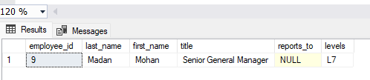

/* Q2: Which countries have the most Invoices? */

select TOP 5 COUNT(*)as c, billing_country

from invoice

group by billing_country

order by billing_country desc

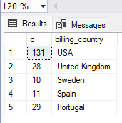

/* Q3: What are top 3 values of total invoice? */

select TOP 3 total from invoice

order by total desc

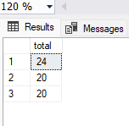

/* Q4: Which city has the best customers? We would like to throw a promotional Music Festival in the city we made the most money.

Write a query that returns one city that has the highest sum of invoice totals.

Return both the city name & sum of all invoice totals */

select sum(total) as invoice_total, billing_city

from invoice

group by billing_city

order by invoice_total desc

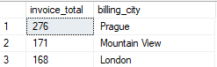

/* Q5: Who is the best customer? The customer who has spent the most money will be declared the best customer.

Write a query that returns the person who has spent the most money.*/

SELECT TOP 1 customer.customer_id, customer.first_name, customer.last_name, SUM(invoice.total) AS total_spending

FROM customer

JOIN invoice ON customer.customer_id = invoice.customer_id

GROUP BY customer.customer_id, customer.first_name, customer.last_name

ORDER BY total_spending DESC

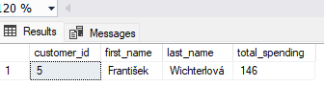

/* Question Set 2 - Moderate */

/* Q1: Write query to return the email, first name, last name, & Genre of all Rock Music listeners.

Return your list ordered alphabetically by email starting with A. */

SELECT DISTINCT email AS Email,first_name AS FirstName, last_name AS LastName, genre.name AS Name

FROM customer

JOIN invoice ON invoice.customer_id=customer.customer_id

JOIN invoice_line ON invoice_line.invoice_id = invoice.invoice_id

JOIN track ON track.track_id = invoice_line.track_id

JOIN genre ON genre.genre_id = track.genre_id

WHERE genre.name LIKE 'Rock'

ORDER BY email;

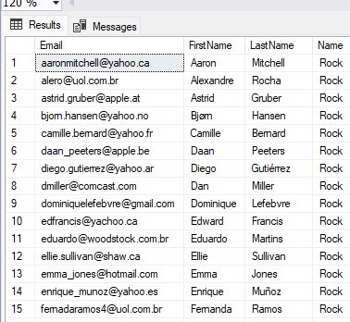

/* Q2: Let's invite the artists who have written the most rock music in our dataset.

Write a query that returns the Artist name and total track count of the top 10 rock bands. */

SELECT TOP 10 artist.artist_id, artist.name, COUNT(track.track_id) AS number_of_songs

FROM track

JOIN album2 ON album2.album_id = track.album_id

JOIN artist ON artist.artist_id = album2.artist_id

JOIN genre ON genre.genre_id = track.genre_id

WHERE genre.name LIKE 'Rock'

GROUP BY artist.artist_id, artist.name

ORDER BY number_of_songs DESC

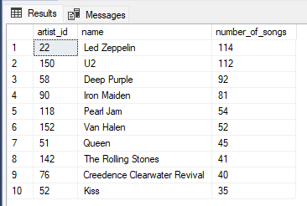

/* Q3: Return all the track names that have a song length longer than the average song length.

Return the Name and Milliseconds for each track. Order by the song length with the longest songs listed first. */

SELECT name,milliseconds

FROM track

WHERE milliseconds > (

SELECT AVG(milliseconds) AS avg_track_length

FROM track )

ORDER BY milliseconds DESC;

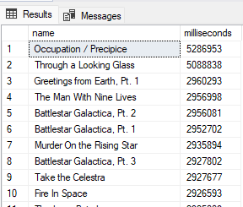

/* Question Set 3 - Advance */

/* Q1: Find how much amount spent by each customer on artists? Write a query to return customer name, artist name and total spent */

/* Steps to Solve: First, find which artist has earned the most according to the InvoiceLines. Now use this artist to find

which customer spent the most on this artist. For this query, you will need to use the Invoice, InvoiceLine, Track, Customer,

Album, and Artist tables. Note, this one is tricky because the Total spent in the Invoice table might not be on a single product,

so you need to use the InvoiceLine table to find out how many of each product was purchased, and then multiply this by the price

for each artist. */

WITH best_selling_artist AS (

SELECT artist.artist_id AS artist_id, artist.name AS artist_name,

SUM(invoice_line.unit_price * invoice_line.quantity) AS total_sales

FROM

invoice_line

JOIN track ON track.track_id = invoice_line.track_id

JOIN album2 ON album2.album_id = track.album_id

JOIN artist ON artist.artist_id = album2.artist_id

GROUP BY artist.artist_id, artist.name

ORDER BY total_sales DESC

OFFSET 0 ROWS

FETCH NEXT 1 ROWS ONLY

)

SELECT c.customer_id, c.first_name, c.last_name, bsa.artist_name,

SUM(il.unit_price * il.quantity) AS amount_spent

FROM invoice i

JOIN customer c ON c.customer_id = i.customer_id

JOIN invoice_line il ON il.invoice_id = i.invoice_id

JOIN track t ON t.track_id = il.track_id

JOIN album2 alb ON alb.album_id = t.album_id

JOIN best_selling_artist bsa ON bsa.artist_id = alb.artist_id

GROUP BY c.customer_id, c.first_name, c.last_name, bsa.artist_name

ORDER BY amount_spent DESC;

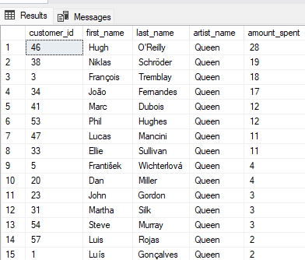

/* Q2: We want to find out the most popular music Genre for each country. We determine the most popular genre as the genre

with the highest amount of purchases. Write a query that returns each country along with the top Genre. For countries where

the maximum number of purchases is shared return all Genres. */

/* Steps to Solve: There are two parts in question- first most popular music genre and second need data at country level. */

/* Method 1: Using CTE */

WITH popular_genre AS

(

SELECT

COUNT(invoice_line.quantity) AS purchases,

customer.country,

genre.name,

genre.genre_id,

ROW_NUMBER() OVER(PARTITION BY customer.country ORDER BY COUNT(invoice_line.quantity) DESC) AS RowNo

FROM

invoice_line

JOIN invoice ON invoice.invoice_id = invoice_line.invoice_id

JOIN customer ON customer.customer_id = invoice.customer_id

JOIN track ON track.track_id = invoice_line.track_id

JOIN genre ON genre.genre_id = track.genre_id

GROUP BY customer.country, genre.name, genre.genre_id

)

SELECT * FROM popular_genre WHERE RowNo = 1

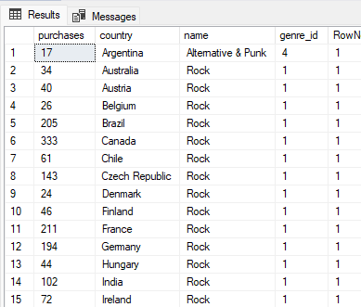

/* Q3: Write a query that determines the customer that has spent the most on music for each country.

Write a query that returns the country along with the top customer and how much they spent.

For countries where the top amount spent is shared, provide all customers who spent this amount. */

/* Steps to Solve: Similar to the above question. There are two parts in question-

first find the most spent on music for each country and second filter the data for respective customers. */

/* Method 1: using CTE */

WITH Customer_with_country AS (

SELECT

customer.customer_id,first_name,last_name,billing_country,

SUM(total) AS total_spending,

ROW_NUMBER() OVER(PARTITION BY billing_country ORDER BY SUM(total) DESC) AS RowNo

FROM

invoice

JOIN customer ON customer.customer_id = invoice.customer_id

GROUP BY

customer.customer_id,first_name,last_name,billing_country

)

SELECT * FROM Customer_with_country WHERE RowNo = 1

